Cub Scout Roundtable Planning Sheet – 60 minute Format
Topic: Planning Safely – The Sweet Sixteen of BSA Safety/ BSA Safety Moments/Safety Checklists
Take Away: Protect our youth and volunteer leaders by planning safely. Units can learn about BSA Safety Moments, how to present them, and incorporate them into their monthly meetings. They can also use The Sweet Sixteen of BSA Safety, the Safety PAUSE and safety checklists to plan safely.

Time Allotted | Activity | Assigned To | Content Ideas | Notes for Media Team
5 min | Opening Ceremony | Cub RT Staff or participants | Flag Ceremony
40 min | General Session (All) | Cub RT Staff and participants | Proper planning for all Scouting activities is important. Planning safely will help ensure a fun, exciting, and safe activity for everyone participating.  BSA has introduced a new series, Safety Moments, which allows leaders to choose a topic and learn about it.  Share a different Safety Moment Topic with your pack monthly via a pack newsletter, social media, or a hands-on activity at a pack meeting or pack committee meeting.  Topics of the series include incident reporting helps, safe use of medication in Scouting, the tour and activity plan, weather-related safety, winter activity, and winter sports.  And here is how you can present a Safety Moment on You Tube:  https://video.search.yahoo.com/search/video?fr=aaplw&p=BSA+Safety+memonts+on+you+tube#id=1&vid=2119669c07266694af72ec860bb7b83b&action=click  or BSA Safety Moment Website:  http://www.scouting.org/scoutsource/HealthandSafety/Safety_Moments.aspx  Using the information shared in the You Tube video or website, present the BSA Safety Moment on Family Camping. Have a copy for each participant.  Review the The Sweet Sixteen of BSA Safety and Safety PAUSE and safety checklists.  (Link for topics located in the resource information.)  Questions to invoke discussion:  - What tools are available to help leaders plan events, campouts, and activities safely?  - The Sweet Sixteen of BSA Safety  - Safety Moments (as shared above)  - Checklists such as: Campout Safety Checklist, Event Safety Checklist  Take time to review. May want to give each participant a copy so that they can follow along.  - What is Safety PAUSE? Have cards printed – one for each participant.  - Who is responsible for making sure that safety procedures are followed?  Activity –  Ask for a volunteer to share with the group an upcoming camping event or outdoor activity. Depending on the size of your group, either 1) Have the volunteer tell about his/her event and then using the Sweet Sixteen of BSA Safety, review to see if they have considered safety or planned safely when planning their event; or 2) As the volunteer discusses the activity, have members of the group raise their hand as they hear something in the Sweet Sixteen of BSA Safety.  In closing, remind the leaders that there are many resources and tools available to them to make a plan. Being attentive to safety concerns when planning their activities will ensure fun and safety for those attending.
10 min | Q & A | Cub Scout RT Staff | Opportunity to answer any additional safety and planning questions.
5 min | Closing | Cub Scout RTC | Perform the Be Prepared Skit. See Resource page.

Resource Information
Tips for Pack Activities
(Insert this graphic from the Safety Moments link shown below)
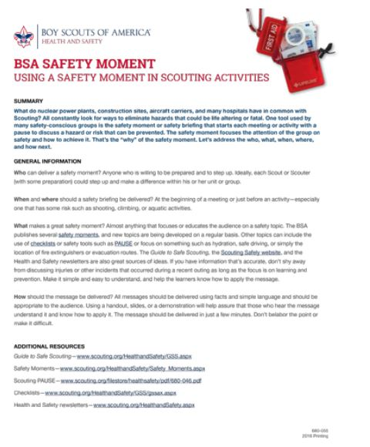
General Session –
The Sweet Sixteen of BSA Safety: The Sweet Sixteen of BSA Safety/ Safety PAUSE/Safety Checklists
The links below provide information on The Sweet Sixteen of BSA Safety, Safety PAUSE and Safety Moments
http://www.scouting.org/scoutsource/HealthandSafety/Resources/sweet16.aspx
Safety PAUSE: http://www.scouting.org/filestore/healthsafety/pdf/680-046.pdf
Safety – Moments and How to Present a Safety Moment: http://www.scouting.org/scoutsource/HealthandSafety/Safety_Moments.aspx
You Tube – Presenting a Safety Moment
https://video.search.yahoo.com/search/video?fr=aaplw&p=BSA+Safety+memonts+on+you+tube#id=1&vid=2119669c07266694af72ec860bb7b83b&action=click
Checklists for Assessing Risks:
http://www.scouting.org/scoutsource/HealthandSafety/GSS/gssax.aspx
Event Safety Checklist:
www.scouting.org/filestore/HealthSafety/pdf/event_checklist.pdf
Campout Safety Checklist:
www.scouting.org/filestore/HealthSafety/pdf/campout_checklist.pdf
How to present a safety moment: http://www.scouting.org/scoutsource/HealthandSafety/Safety_Moments.aspx or
Closing:

Be Prepared
First Scout walks to center of stage, stands to attention, salutes and says, "BE PREPARED." This is repeated by three other Scouts. When they are all standing side by side, a loud motor horn or explosion is let off behind the audience.
The Scouts then all say, 'WE TOLD YOU TO BE PREPARED'
[Source http://www.macscouter.com/skits/BBSkits_A-B.asp]

